Evolution Study Guide
Name_______________________
- What is the theory evolution?
The theory by which populations of organisms slowly change over time to become well-suited to their environment
- What is natural selection? Who proposed Evolution through natural selection?
The process by which evolution occurs and in which certain genes make organisms more likely to survive and reproduce. Charles Darwin proposed evolution happens through natural selection.
- Give an example of natural selection in action.
Insects developing a resistance to an insecticide and passing the trait down to their offspring.
- What evidence is available today that Darwin did not have access to during his time?
DNA and how organisms inherit their traits.
- Define adaptation and give examples.
A characteristic that improves an individual’s ability to survive and reproduce in a particular environment
Elephants not having tusks. Giraffes having long necks.
- What cause adaptations and how do they help with an organism survival?
Mutations and inherited variations cause adaptations. It helps them become better suited for their environment.

- How are natural selection, adaptation, and survival interrelated?
Natural selection leads to organisms that possess heritable traits that enable them to better adapt to their environment compared with other members of their species will be more likely to survive, reproduce, and pass more of their genes on to the next generation.

- Define species.
a group of living organisms consisting of similar individuals capable of exchanging genes or interbreeding.

- What is speciation? Give an example.
The process often begins when a portion of a population becomes physically or geographically separated and ends when the two populations cannot interbreed anymore.
An example of speciation is the Galápagos finch
- Describe how populations of organisms are limited?
Starvation, disease, competition, and predation

- What is a fossil and where are they commonly found?
Fossils are trace remains of an organism that lived long ago and are most commonly preserved in sedimentary rocks.
- What does the fossil record provide scientist?
It provides information about organisms that have lived in the past.

- What types of plant and animal parts are usually found in fossils?
hard parts such as bones, teeth, and shells.

- Fossils have been found that look similar to organisms today. What does this tell scientist?
That they have either been on earth a long time or they are ancestors of today’s organisms.
- What are the pieces of evidence that support evolution from a common ancestor?
Physical traits, fossils and DNA
- Eagles have keen eyesight that allows them to spot mice and other prey while soaring high above the ground. How would a biologist explain how eagles evolved their keen eye sight, assuming their ancestors had less keen eyesight?
They eagles with better eye sight were able to get the mice and survive. This trait was then passed down to their offspring.

- Cheetahs are able to run faster than 60 miles per hour when chasing prey. How would a biologist explain how the ability to run this fast evolved in cheetahs, assuming their ancestors could only run 20 miles per hour?
The cheetahs that developed the ability to run faster were able catch their prey and survive. This trait was then passed down to the next generations.
- Polar bears have white fur that blends in well with their snowy surroundings. This helps polar bears stalk and hunt seals. Polar bears are believed to have evolved from bears that had brown fur. How would a biologist explain how the white fur of polar bears evolved from bears with brown fur?
There was a mutation in the DNA of the bears of white fur. The white fur bears were able to blend in with the snow so that they could hunt for their prey. The white fur bears were able to survive and pass the trait down to their offspring.

- A ship that had been used for many years in arctic exploration was sold and moved to a harbor in the warm waters of the Caribbean. Worms that had lived on the ship bottom crawled off in the warm waters and attempted to attach to other ships in this tropical area where there were no similar worms. Some of the worms were able to survive and reproduce. What would you expect to happen to this group of worms over many generations in this new environment?
a) The worms will mate and produce offspring just as they did in their previous environment, and the group’s traits will likely remain unchanged after many generations.
b) The worms will gain new, more complex traits through natural selection that will help them better adapt to the warmer waters because natural selection leads to more complex and better adapted organisms.
c) Worms possessing genetic variations that help them to survive and thrive in the new environment will leave more offspring than others lacking those traits. Over time, the proportion of the worm population with these adaptive traits will likely increase.
d) The mutation rate will increase in this group of worms in order to promote evolution.

- Bacillus thuringienses (Bt) bacteria produce a natural insecticide. Widespread use of Bt has lead to Bt resistance among insects. Why is this occurring?
a) Individual insects that have mutations providing resistance to Bt can survive in the presence of Bt. The survivors pass this Bt resistance on to their offspring.
b) Bt-resistant insects increase in the population by chance. There are so many insects that some of them are resistant to each type of insecticide.
c) In the presence of Bt, individual insects evolve to become Bt resistant.
d) Natural selection causes insects to generate genes providing resistance to Bt.

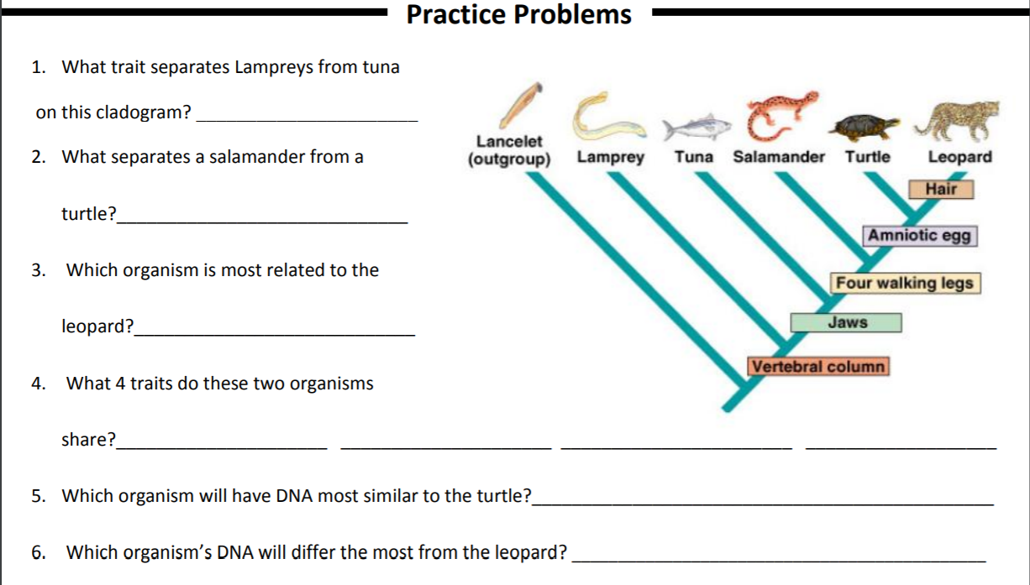
lancelet
leopard
Vertebral column
Amniotic egg
4 walking legs
jaws
Turtle
4 walking legs
Jaws

