Human Body Systems Interactions – Study Guide KEY
Levels of Organization Fill-in-the-Blank
- Cells work together to form __tissues___. __Tissues_____ work together to form organs. Organs work together to form _organ_ _systems___. __Organ____ _systems_____ make up organisms.
- Word = __cell________
Sentence = __tissue________
Word Bank for Questions #1 & #2:
cell organ tissue organism organ system
Paragraph = __organ________
Chapter = __organ___ __system___
Book = _organism____
Human Body System Matching
- __G__Nervous System | - The major organs of this system are the lungs. This system allows the body to breathe.
- __E__Integumentary System | - The major organs of this systems are glands that produce chemicals to help control body functions such as growth and development.
- __K__Digestive System | - White blood cells in this system fight pathogens (germs).
- __J__Skeletal System | - The major organs of this system include the tonsils, the spleen, and other lymph nodes that help remove dead pathogens (germs) and other wastes from the body by contracting of skeletal muscles.
- __L__Excretory System | - The major organ of this system is the skin. This system covers and protects the body.
- __D__Lymphatic System | - The 3 types of tissue in this system include smooth, striated, and cardiac. This system provide shape, support, and movement for the body.
- __A__Respiratory System | - The major organs of this system include the brain and spinal cord. This system controls the body.
- __B__Endocrine System | - The major organs of this system include the kidneys and the bladder. The kidneys filter the blood and produce urine that is stored in the bladder until the body is ready to release the waste.
- __F__Muscular System | - The major organs of this system are the heart and the blood vessels. This system provides transportation for nutrients, oxygen, and other substances throughout the body.
- __I__Cardiovascular System | - The human body has 206 bones that help protect the internal organs and a variety of joints that allow movement. This system also produces red blood cells in the marrow of the bones.
- __H__Urinary System | - This system has many organs including the stomach and the intestines. This system is responsible for breaking down food for the body.
- __C__Immune System | - This system consists of 4 other systems that help the body removes wastes. These systems include the integumentary (sweating), respiratory (exhaling carbon dioxide), urinary (releasing urine), and digestive systems (releasing feces).

Systems Interactions
Action | Which body systems are in use  during this action? | How do you know these systems  are part of this action?
Brushing your teeth | skeletal, muscular, nervous, respiration, cardiovascular | respiration and cardiovascular give you energy to move your muscles; the muscles are moving the bones to lift and maneuver the toothbrush to clean the teeth which are also bones; the nervous system is directing the action using information from the senses (eyes, touch, taste)
Scoring a touchdown |  | *answer should include at least nervous, senses, muscular, and skeletal
Texting |  | *answer should include at least nervous, senses, muscular, and skeletal
Eating breakfast |  | *answer should include at least nervous, senses, muscular, skeletal, and digestive

How does the skeletal system interact with the…
- …muscular system? __muscles are attached to bones by tendons; when muscles contract, they pull on the bones causing movement__

- …respiratory system? _the rib cage protects the lung__

- …cardiovascular system? __red blood cells are produced in the marrow bones; the cardiovascular system uses red blood cells to transport oxygen to the body___

- …nervous system? __when muscles receive a signal from the nervous systems, they pull on the bones causing movement__

- …digestive system? __the teeth grind the food to help break it down; the bones store minerals such as calcium and phosphorous__

- …immune system? __movement of the skeletal muscles cause the lymph fluid to be transported throughout the body helping the body get rid of wastes from fighting pathogens (germs)_____

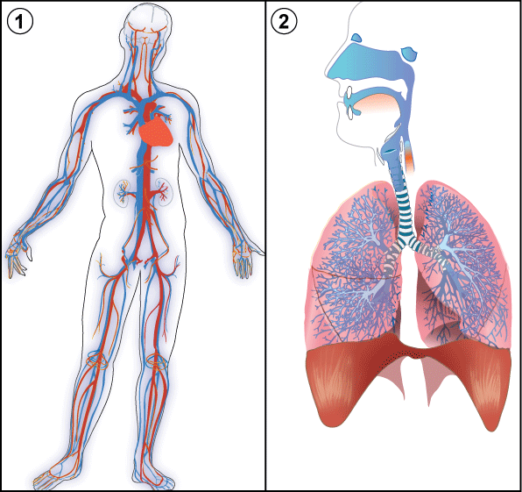
- What 2 systems are pictured in the diagram and
how do they work together?
__The two systems are the cardiovascular (circulatory) system and the respiratory systems. These two systems work together to supply the body with oxygen and get rid of carbon dioxide. The lungs filter oxygen from the environment (inhale) and pass it the blood cell in the cardiovascular system. The heart pumps the blood through the blood vessel to the body. Carbon dioxide passes into the blood from body cells after cellular respiration. The carbon dioxide is then passed from the blood to lungs for release into the environment (exhale).___

