Name___________________________________________________________Per__________________
Chapter 18 Study Guide
- Compare and contrast biotic and abiotic factors.
biotic
abiotic

Non-living

Both parts of an ecosystem

Living

- List the 5 levels in the environment in order from 1st to 5th
  - 1: organism

  - 2: population

  - 3: community

  - 4: ecosystem

  - 5: biosphere
- Draw an example of a food chain:
Ex. Grass-----mosquito----frog-----heron-----alligator or see diagram below
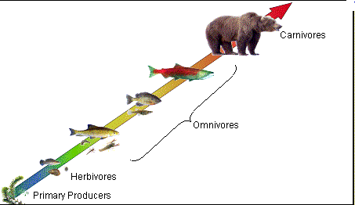

- Define ecology.
Ecology is the study of the interactions of organisms with one another and with their environment
- Describe competition and give an example.

- Description: when 2 or more individuals or populations try to use the same resource such as food, water, shelter, etc

  - Example: Elk in Yellowstone compete for the same food plants; different species of trees compete for sunlight in a forest

- Describe the predator and prey relationship and give an example.

- Description: interaction between species with one organism eating another organism

  - Example: bird & worm

- Describe the three types of symbiotic relationships and give an example
- Mutualism: both organisms benefit

  - Example: plover bird & alligator

- Commensalism: one organism benefits, and the other is unharmed

  - Example: spanish moss & tree

- Parasitism: one organism benefits, but the other is harmed

  - Example: deer tick & human

- Describe the relationship between the parasite and a host organism.
The organism that benefits is called the parasite. The organism that gets hurt is the host.

- Compare and contrast a food chain to a food web.
food web
food chain

shows how energy in food flows from one organism to another

Illustrates transfer of energy between organisms

shows feeding relationships in an ecosystem

- Compare and contrast producers and consumers
producers
consumers

Need energy

Since they can’t make their own energy, they must eat organisms to get energy

Uses sunlight to make their own food/energy

- Describe the three types of consumers
- Herbivore: consumer that eats only plants

- Omnivore: consumer that eats plants and animals

- Carnivore: consumer that eats only animals

- Explain the term decomposer and give an example.
- Description: organism that gets energy by breaking down dead organisms

  - Example: bacteria & fungi

- How is a decomposer different than a scavenger?
Scavengers eat the dead plants and organisms. (turkey vulture)
Decomposers break down the dead organisms (bacteria)
- Explain the difference in 1st, 2nd, and 3rd order consumers.
1st order consumers eat producers, so they are herbivores (sheep). 2nd order consumers eat the 1st order consumers, so they are carnivores (fox). 3rd order consumers eat the secondary consumers (hawk).
- How does the energy travel in an energy pyramid?
Whatever energy is not used by the organism is stored in its tissues.
More energy is available at the bottom than at the top, so the number the number of organisms decrease as you go up.
- Where is the energy in the pyramid the most abundant?
The energy in the pyramid is the most abundant at the bottom.

- Explain the term, limiting factor, and give 2 examples.
- Description: a resource so scarce it limits the size of a population

  - 2 Examples: food, shelter

18. Draw an example of a food web.
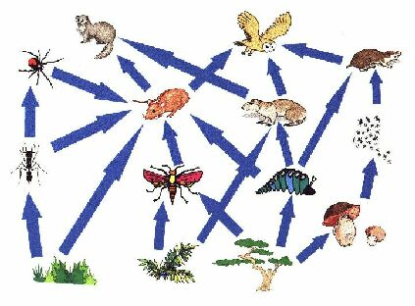

Be able to:
- Read a food web and a food chain
- Identify biotic and abiotic factors
- Define all terms in Chapter 18
- Identify examples of symbiosis, limiting factors, energy pyramids, predators and prey, and each level of the environmental organization system.
- Identify examples of herbivores, omnivores, and carnivores

