Vocabulary
Check the box to show whether each statement is true or false.
T | F
□ | □ | 1. Photosynthesis is the process in which cells use oxygen to break down food and release stored energy.
□ | □ | 2. A molecule is made up of atoms that are joined together.
□ | □ | 3. A eukaryote has cells that do not contain a nucleus, whereas a prokaryote has cells that have a nucleus.
Key Concepts
Read each question below, and circle the best answer.
4. Which of the following substances must animal cells take in from the environment to maintain homeostasis?
A. DNA
B. oxygen
C. chlorophyll
D. carbon dioxide
5. Which molecule is a source of energy, a store of energy in the body, and can mix with water?
A. lipid C. nucleic acid
B. chlorophyll D. carbohydrate
6. Which method of material exchange uses up energy?
A. osmosis C. active transport
B. diffusion D. passive transport
7. The following diagram shows a common cell organelle.
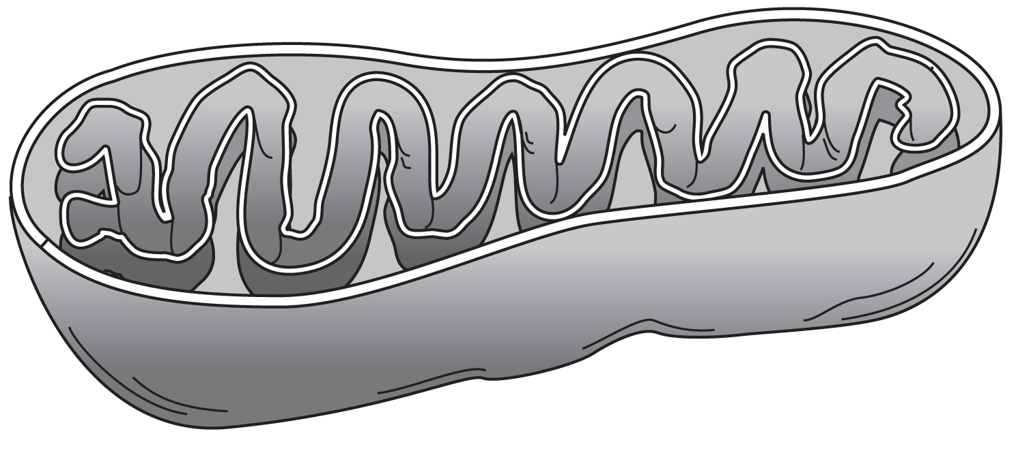
What process takes place in the organelle shown?
A. photosynthesis C. cellular respiration
B. protein synthesis D. packaging of proteins
8. Which statement correctly tells why the cells of unicellular and multicellular organisms divide?
A. The cells of unicellular organisms divide to reproduce; those of multicellular organisms divide to replace cells and to grow.
B. The cells of unicellular organisms divide to replace cells and to grow; those of multicellular organisms divide to reproduce.
C. The cells of both kinds of organisms divide to reproduce.
D. The cells of both kinds of organisms divide to replace cells and to grow.
Critical Thin king
Answer the following questions in the space provided.
9. The following diagram shows a cell that Dimitri saw on his microscope slide.
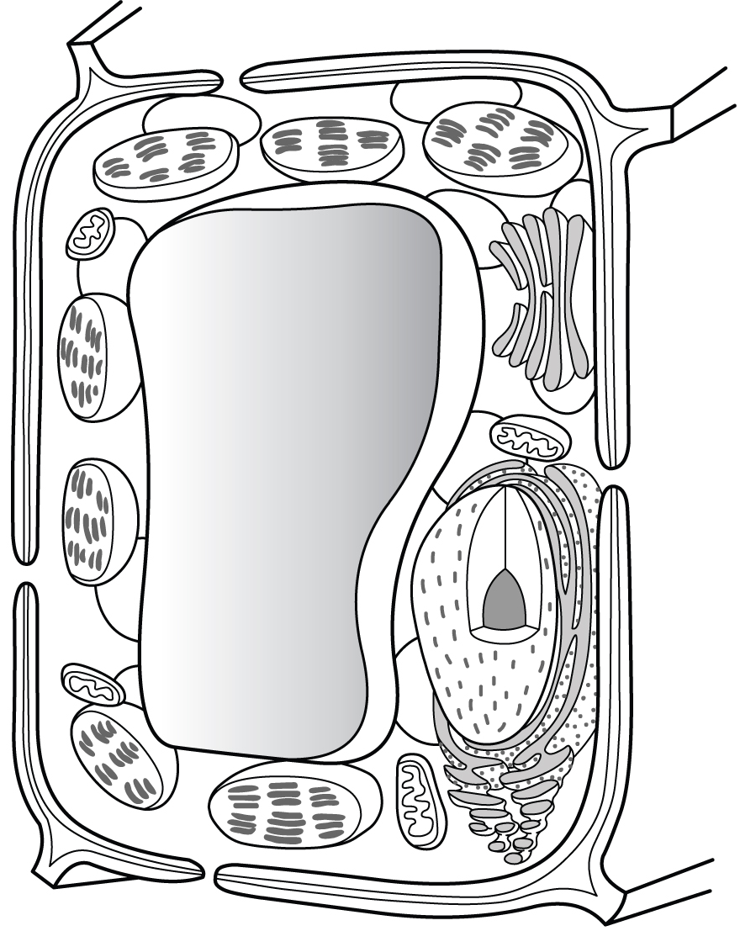
Dimitri’s teacher gave him an unlabeled slide of some cells and asked him to identify whether the cells were plant cells or animal cells. Dimitri examined the slide under a microscope and concluded that the cells were plant cells. How did Dimitri reach his conclusion? Is his conclusion correct? What life process can these cells carry out that a cell from another kind of multicellular organism cannot?
Shape – rectangular
Organelles – large central vacuole, chloroplast, and cell wall

10. One of the characteristics of living things is that they respond to external changes in their environment so that their internal environment stays as stable as possible. Why must an organism do this? Name an environmental change that an animal must respond to in order to keep a stable internal environment. What might happen to an organism if it could not adapt to an external change?

Happens for survival – proper functioning of cells is necessary for cell to survive
Change in temperature – too hot will overheat the organism (in humans, heatstroke and death), too cold with shut down the organism (in humans hypothermia and death)
 essential QuestionS
Answer the following question in the space provided.
11. The following picture shows the process of photosynthesis.
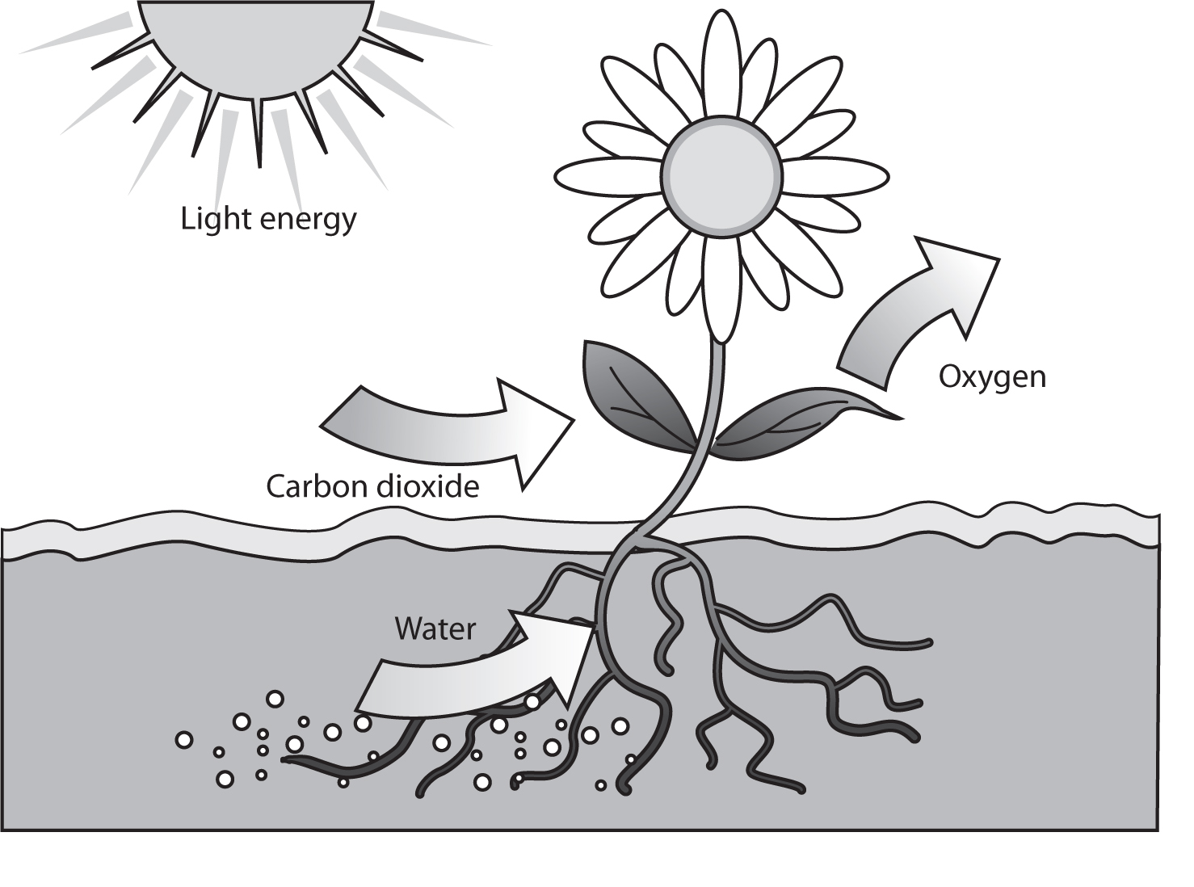
In which plant organ and organelle does photosynthesis take place? One of the products of photosynthesis is missing from the diagram. What is this missing product? Describe the role of this substance in cells. How do animals get this substance?
Organ = leaves
Organelle = chloroplasts
Missing glucose – stored as a simple sugar called glucose, used for energy, animals get it from eating producers or other consumers that ate producers

