Objectives
- Identify the different parts of a eukaryotic cell.
- Explain the function of each part of a eukaryotic cell.

Cell Wall
- Some eukaryotic cells have cell walls. A cell wall is a rigid structure that gives support to a cell. The cell wall is the outermost structure of a cell.
- Plants and algae have cell walls made of a complex sugar called cellulose. The cell walls of plant cells help plants retain their shape.
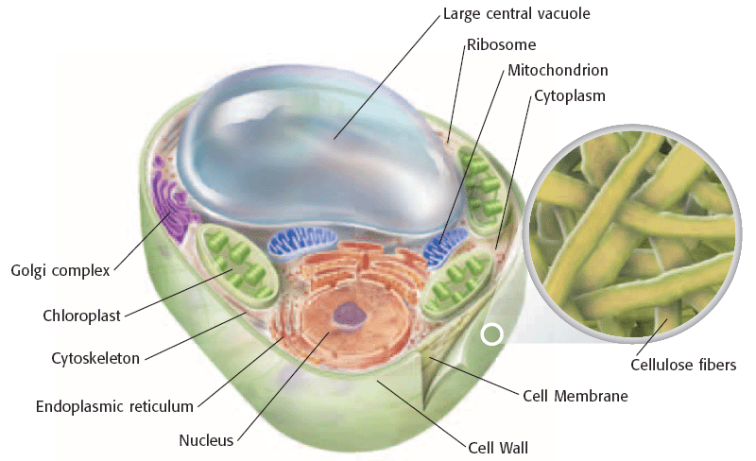
Cell Membrane
- All cells have cell membranes. The cell membrane is a protective barrier that encloses a cell.
- The cell membrane is the outermost structure in cells that lack a cell wall. In cells that have a cell wall, the cell membrane lies just inside the cell wall.
- The cell membrane contains proteins, lipids, and phospholipids.
- Lipids are a group of compounds that do not dissolve in water. Lipids are “water fearing” or hydrophobic.
- Phospholipids are lipids that contain phosphorus. The phosphorus containing ends of phospholipids are “water loving” or hydrophilic.
- The cell membrane is made of two layers of phospholipids. It allows nutrients to enter and wastes to exit the cell.
- 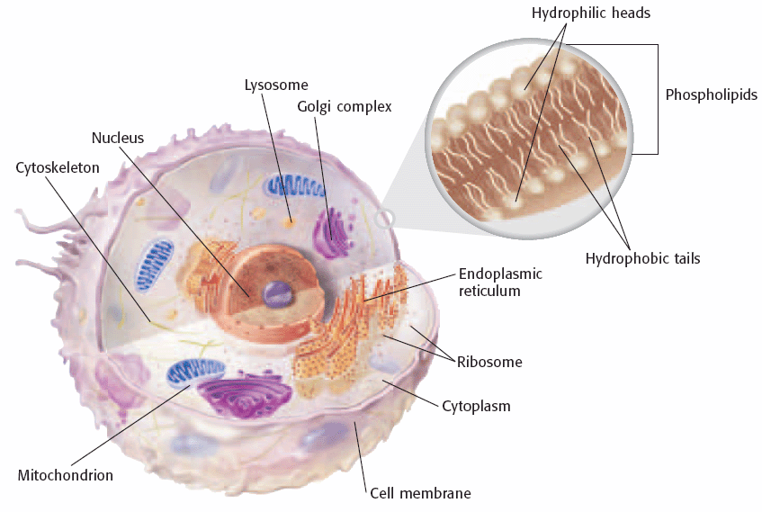

Cytoskeleton
- The cytoskeleton is a web of proteins in the cytoplasm. It acts as both a muscle and a skeleton.
- The cytoskeleton keeps the cell’s membranes from collapsing and helps some cells move.
- The cytoskeleton is made of three types of protein. One protein is a hollow tube and the other two are long, stringy fibers.

Nucleus
- The nucleus is a membrane-bound organelle that contains the cell’s DNA. DNA contains the information on how to make a cell’s proteins.
- Messages for how to make proteins are copied from the DNA. These messages are then sent out of the nucleus through the membranes.
- The nucleus is covered by two membranes. Materials cross this double membrane through pores.

Ribosomes
- Organelles that make proteins are called ribosomes. Unlike most organelles, ribosomes are not covered by a membrane.
- Proteins are made of organic molecules called amino acids. All cells need proteins to live. All cells have ribosomes.

Endoplasmic Reticulum
- The endoplasmic reticulum (ER) is a system of folded membranes in which proteins, lipids, and other materials are made.
- The ER is part of the internal delivery system of the cell. Substances move through the ER to different places in the cell.
- Endoplasmic reticulum is either rough ER or smooth ER. The part of the ER covered in ribosomes is rough ER. ER that lacks ribosomes is smooth ER.
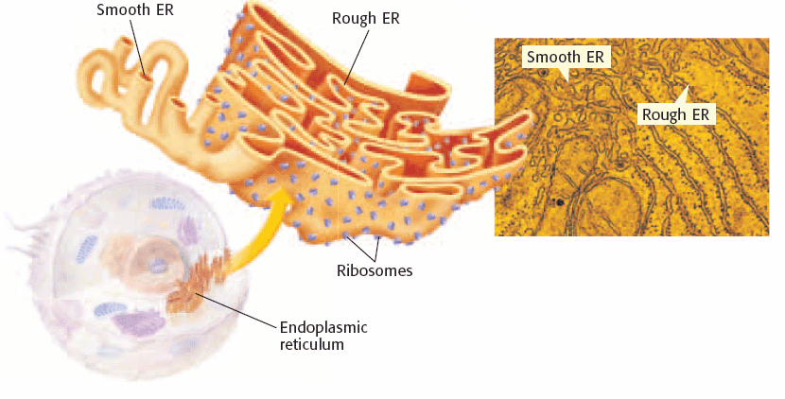

Mitochondria
- A mitochondrion is the organelle in which sugar is broken down to produce energy. Mitochondria are the main power source of a cell.
- Mitochondria are covered by two membranes, as shown at right.
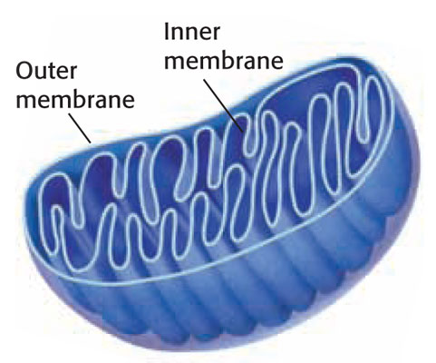

Chloroplasts
- Chloroplasts are organelles in plant and algae cells in which photosynthesis takes place. Photosynthesis is the process by which plants and algae use sunlight, carbon dioxide, and water to make sugar and oxygen.
- Chloroplasts are covered by two membranes, as shown at right.

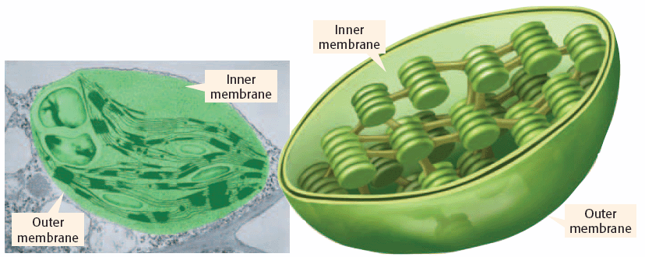

Golgi Complex
- The organelle that packages and distributes proteins is called the Golgi complex. The Golgi complex modifies lipids and proteins to do different jobs.
- Final products are enclosed in a piece of the Golgi complex membrane, which pinches off to form a small bubble.
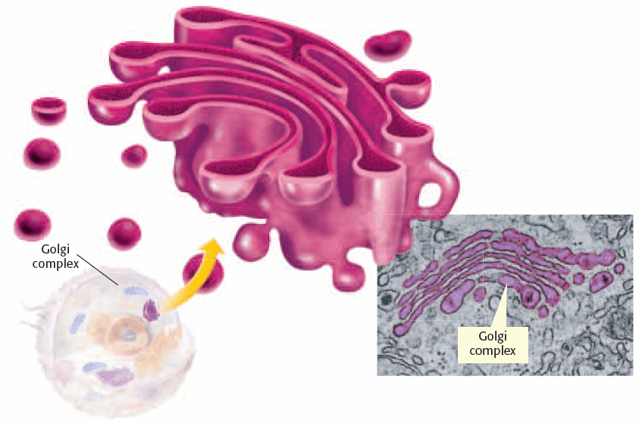

Cell Compartments
- The bubble that forms from the Golgi complex membrane is a vesicle. A vesicle is a small sac that surrounds material to be moved into or out of cell.
- Vesicles also move material within a cell. Vesicles carry new proteins from the ER to the Golgi complex. Other vesicles distribute material from the Golgi complex to other parts of the cell.

Cellular Digestion

- Lysosomes are vesicles found mainly in animal cells that are responsible for digestion inside a cell. Lysosomes are organelles that contain digestive enzymes.
- Lysosomes destroy worn-out or damaged organelles, get rid of waste materials, and protect the cell from foreign invaders.
- Vacuoles are vesicles.
- In plant and fungal cells, some vacuoles act like lysosomes. The large central vacuole in plant cells stores water and other liquids.
